获取jira侧问题详情接口：

请求地址：http://10.223.69.27:9089/open/issueInfo/{issuekey}
请求方式：GET
请求参数：issuekey
Headers:
username:：e9d9bfa527da969425825c7c4f0b24916f248dd549d1507f45f5c148cac83e30
password：77004579fe653040a064df6e56e9038fedf97743718127d99defc788347c6462

postMain：
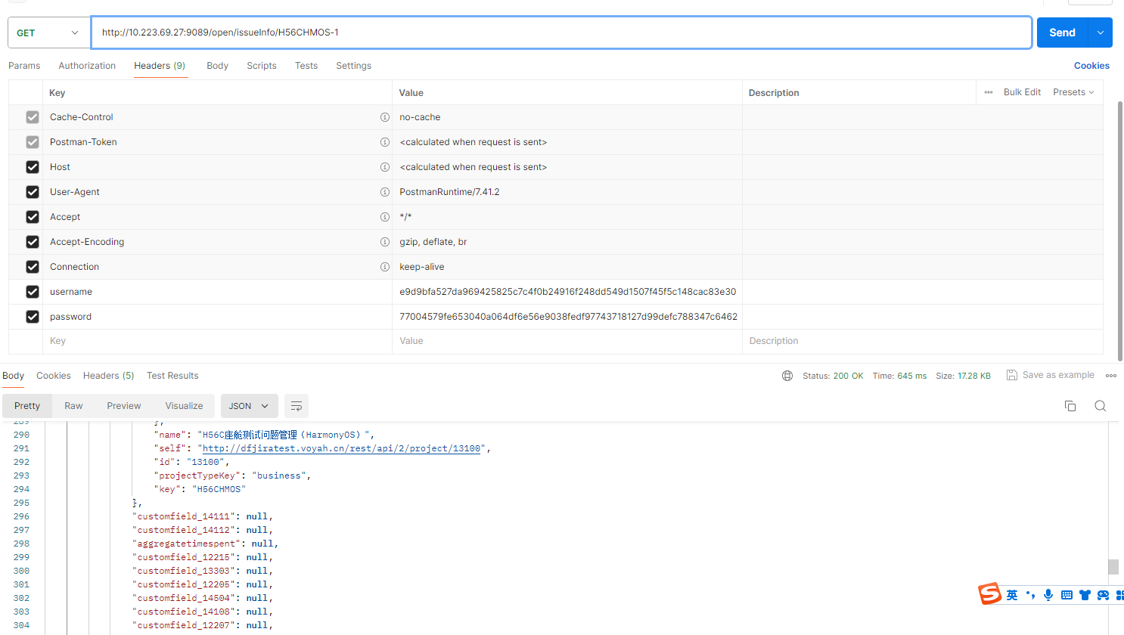

返回参数
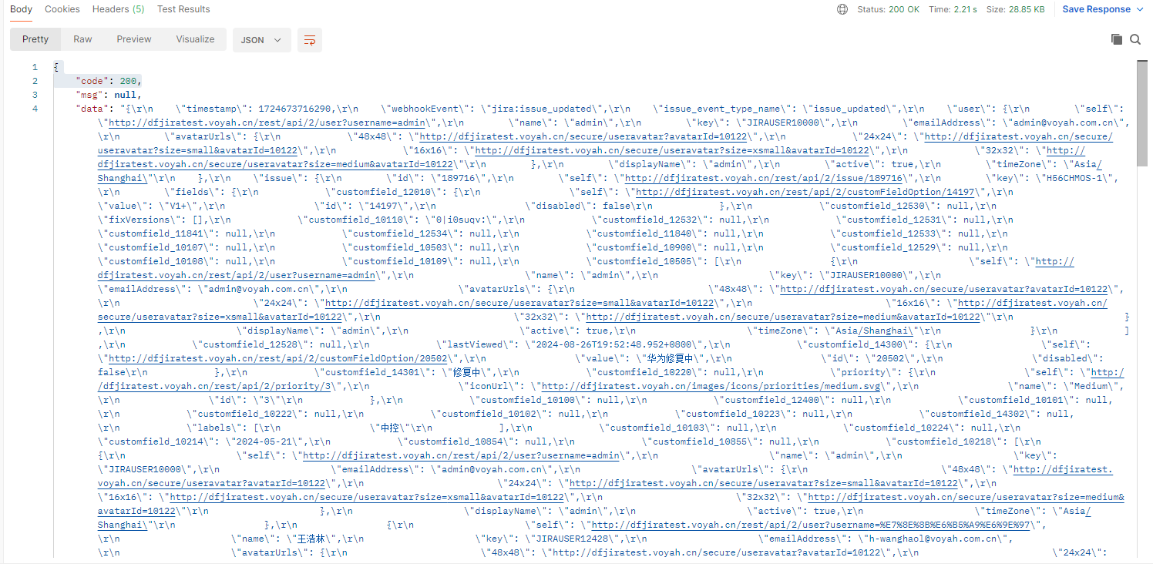

返回参数完整：
{
"code": 200,
"msg": null,
"data": {
"issue": {
"self": "http://dfjiratest.voyah.cn/rest/api/2/issue/189716",
"id": "189716",
"fields": {
"customfield_12010": {
"self": "http://dfjiratest.voyah.cn/rest/api/2/customFieldOption/14197",
"disabled": false,
"id": "14197",
"value": "V1+"
},
"customfield_12530": null,
"fixVersions": [],
"customfield_10110": "0|i0suqv:",
"customfield_12532": null,
"customfield_12531": null,
"customfield_11841": null,
"customfield_12534": null,
"customfield_11840": null,
"customfield_12533": null,
"customfield_10107": null,
"customfield_10503": null,
"customfield_10900": null,
"customfield_12529": null,
"customfield_10108": null,
"customfield_10109": null,
"customfield_10505": [
{
"emailAddress": "admin@voyah.com.cn",
"avatarUrls": {
"48x48": "http://dfjiratest.voyah.cn/secure/useravatar?avatarId=10122",
"24x24": "http://dfjiratest.voyah.cn/secure/useravatar?size=small&avatarId=10122",
"16x16": "http://dfjiratest.voyah.cn/secure/useravatar?size=xsmall&avatarId=10122",
"32x32": "http://dfjiratest.voyah.cn/secure/useravatar?size=medium&avatarId=10122"
},
"displayName": "admin",
"name": "admin",
"self": "http://dfjiratest.voyah.cn/rest/api/2/user?username=admin",
"active": true,
"timeZone": "Asia/Shanghai",
"key": "JIRAUSER10000"
}
],
"customfield_12528": null,
"lastViewed": "2024-08-26T19:52:48.952+0800",
"customfield_14300": {
"self": "http://dfjiratest.voyah.cn/rest/api/2/customFieldOption/20502",
"disabled": false,
"id": "20502",
"value": "华为修复中"
},
"customfield_14301": "修复中",
"customfield_10220": null,
"priority": {
"name": "Medium",
"self": "http://dfjiratest.voyah.cn/rest/api/2/priority/3",
"iconUrl": "http://dfjiratest.voyah.cn/images/icons/priorities/medium.svg",
"id": "3"
},
"customfield_10100": null,
"customfield_12400": null,
"customfield_10101": null,
"customfield_10222": null,
"customfield_10102": null,
"customfield_10223": null,
"customfield_14302": null,
"labels": [
"中控"
],
"customfield_10103": null,
"customfield_10224": null,
"customfield_10214": "2024-05-21",
"customfield_10854": null,
"customfield_10855": null,
"customfield_10218": [
{
"emailAddress": "admin@voyah.com.cn",
"avatarUrls": {
"48x48": "http://dfjiratest.voyah.cn/secure/useravatar?avatarId=10122",
"24x24": "http://dfjiratest.voyah.cn/secure/useravatar?size=small&avatarId=10122",
"16x16": "http://dfjiratest.voyah.cn/secure/useravatar?size=xsmall&avatarId=10122",
"32x32": "http://dfjiratest.voyah.cn/secure/useravatar?size=medium&avatarId=10122"
},
"displayName": "admin",
"name": "admin",
"self": "http://dfjiratest.voyah.cn/rest/api/2/user?username=admin",
"active": true,
"timeZone": "Asia/Shanghai",
"key": "JIRAUSER10000"
},
{
"emailAddress": "h-wanghaol@voyah.com.cn",
"avatarUrls": {
"48x48": "http://dfjiratest.voyah.cn/secure/useravatar?avatarId=10122",
"24x24": "http://dfjiratest.voyah.cn/secure/useravatar?size=small&avatarId=10122",
"16x16": "http://dfjiratest.voyah.cn/secure/useravatar?size=xsmall&avatarId=10122",
"32x32": "http://dfjiratest.voyah.cn/secure/useravatar?size=medium&avatarId=10122"
},
"displayName": "王浩林",
"name": "王浩林",
"self": "http://dfjiratest.voyah.cn/rest/api/2/user?username=%E7%8E%8B%E6%B5%A9%E6%9E%97",
"active": true,
"timeZone": "Asia/Shanghai",
"key": "JIRAUSER12428"
}
],
"aggregatetimeoriginalestimate": null,
"timeestimate": null,
"versions": [],
"customfield_11703": null,
"issuelinks": [],
"assignee": {
"emailAddress": "admin@voyah.com.cn",
"avatarUrls": {
"48x48": "http://dfjiratest.voyah.cn/secure/useravatar?avatarId=10122",
"24x24": "http://dfjiratest.voyah.cn/secure/useravatar?size=small&avatarId=10122",
"16x16": "http://dfjiratest.voyah.cn/secure/useravatar?size=xsmall&avatarId=10122",
"32x32": "http://dfjiratest.voyah.cn/secure/useravatar?size=medium&avatarId=10122"
},
"displayName": "admin",
"name": "admin",
"self": "http://dfjiratest.voyah.cn/rest/api/2/user?username=admin",
"active": true,
"timeZone": "Asia/Shanghai",
"key": "JIRAUSER10000"
},
"status": {
"name": "Open",
"self": "http://dfjiratest.voyah.cn/rest/api/2/status/1",
"description": "开口问题",
"iconUrl": "http://dfjiratest.voyah.cn/images/icons/statuses/open.png",
"id": "1",
"statusCategory": {
"colorName": "blue-gray",
"name": "待办",
"self": "http://dfjiratest.voyah.cn/rest/api/2/statuscategory/2",
"id": 2,
"key": "new"
}
},
"components": [],
"customfield_13324": null,
"customfield_13323": null,
"customfield_10212": {
"self": "http://dfjiratest.voyah.cn/rest/api/2/customFieldOption/10026",
"disabled": false,
"id": "10026",
"value": "总是"
},
"customfield_13326": null,
"customfield_10213": null,
"customfield_13325": null,
"customfield_12107": null,
"customfield_12503": null,
"customfield_12106": null,
"customfield_12502": null,
"customfield_12505": null,
"customfield_11811": null,
"customfield_10206": null,
"customfield_12108": null,
"customfield_12900": null,
"customfield_10207": {
"emailAddress": "admin@voyah.com.cn",
"avatarUrls": {
"48x48": "http://dfjiratest.voyah.cn/secure/useravatar?avatarId=10122",
"24x24": "http://dfjiratest.voyah.cn/secure/useravatar?size=small&avatarId=10122",
"16x16": "http://dfjiratest.voyah.cn/secure/useravatar?size=xsmall&avatarId=10122",
"32x32": "http://dfjiratest.voyah.cn/secure/useravatar?size=medium&avatarId=10122"
},
"displayName": "admin",
"name": "admin",
"self": "http://dfjiratest.voyah.cn/rest/api/2/user?username=admin",
"active": true,
"timeZone": "Asia/Shanghai",
"key": "JIRAUSER10000"
},
"customfield_11814": null,
"aggregatetimeestimate": null,
"customfield_10208": [
{
"self": "http://dfjiratest.voyah.cn/rest/api/2/customFieldOption/10000",
"disabled": false,
"id": "10000",
"value": "整车台架-EV"
},
{
"self": "http://dfjiratest.voyah.cn/rest/api/2/customFieldOption/10001",
"disabled": false,
"id": "10001",
"value": "实车"
},
{
"self": "http://dfjiratest.voyah.cn/rest/api/2/customFieldOption/10003",
"disabled": false,
"id": "10003",
"value": "HIL"
},
{
"self": "http://dfjiratest.voyah.cn/rest/api/2/customFieldOption/12513",
"disabled": false,
"id": "12513",
"value": "台架"
}
],
"customfield_12506": null,
"customfield_10847": null,
"creator": {
"emailAddress": "admin@voyah.com.cn",
"avatarUrls": {
"48x48": "http://dfjiratest.voyah.cn/secure/useravatar?avatarId=10122",
"24x24": "http://dfjiratest.voyah.cn/secure/useravatar?size=small&avatarId=10122",
"16x16": "http://dfjiratest.voyah.cn/secure/useravatar?size=xsmall&avatarId=10122",
"32x32": "http://dfjiratest.voyah.cn/secure/useravatar?size=medium&avatarId=10122"
},
"displayName": "admin",
"name": "admin",
"self": "http://dfjiratest.voyah.cn/rest/api/2/user?username=admin",
"active": true,
"timeZone": "Asia/Shanghai",
"key": "JIRAUSER10000"
},
"subtasks": [],
"customfield_14400": "版本1",
"reporter": {
"emailAddress": "admin@voyah.com.cn",
"avatarUrls": {
"48x48": "http://dfjiratest.voyah.cn/secure/useravatar?avatarId=10122",
"24x24": "http://dfjiratest.voyah.cn/secure/useravatar?size=small&avatarId=10122",
"16x16": "http://dfjiratest.voyah.cn/secure/useravatar?size=xsmall&avatarId=10122",
"32x32": "http://dfjiratest.voyah.cn/secure/useravatar?size=medium&avatarId=10122"
},
"displayName": "admin",
"name": "admin",
"self": "http://dfjiratest.voyah.cn/rest/api/2/user?username=admin",
"active": true,
"timeZone": "Asia/Shanghai",
"key": "JIRAUSER10000"
},
"customfield_12101": null,
"customfield_12100": null,
"aggregateprogress": {
"total": 0,
"progress": 0
},
"customfield_12103": null,
"customfield_12102": null,
"customfield_10201": "2024-05-22",
"customfield_12105": null,
"customfield_10202": "2024-05-23",
"customfield_12104": null,
"customfield_11801": null,
"customfield_13704": null,
"customfield_11800": null,
"customfield_13703": null,
"customfield_11802": null,
"customfield_13705": null,
"progress": {
"total": 0,
"progress": 0
},
"worklog": {
"total": 0,
"maxResults": 20,
"startAt": 0,
"worklogs": []
},
"issuetype": {
"avatarId": 10307,
"name": "H56C-HMOS问题",
"self": "http://dfjiratest.voyah.cn/rest/api/2/issuetype/12700",
"description": "",
"id": "12700",
"iconUrl": "http://dfjiratest.voyah.cn/secure/viewavatar?size=xsmall&avatarId=10307&avatarType=issuetype",
"subtask": false
},
"customfield_14110": null,
"timespent": null,
"customfield_14113": null,
"customfield_14114": null,
"project": {
"avatarUrls": {
"48x48": "http://dfjiratest.voyah.cn/secure/projectavatar?avatarId=10324",
"24x24": "http://dfjiratest.voyah.cn/secure/projectavatar?size=small&avatarId=10324",
"16x16": "http://dfjiratest.voyah.cn/secure/projectavatar?size=xsmall&avatarId=10324",
"32x32": "http://dfjiratest.voyah.cn/secure/projectavatar?size=medium&avatarId=10324"
},
"name": "H56C座舱测试问题管理（HarmonyOS）",
"self": "http://dfjiratest.voyah.cn/rest/api/2/project/13100",
"id": "13100",
"projectTypeKey": "business",
"key": "H56CHMOS"
},
"customfield_14111": null,
"customfield_14112": null,
"aggregatetimespent": null,
"customfield_12215": null,
"customfield_13303": null,
"customfield_12205": null,
"customfield_14504": null,
"customfield_14108": null,
"customfield_12207": null,
"customfield_14109": null,
"resolutiondate": null,
"workratio": -1,
"watches": {
"self": "http://dfjiratest.voyah.cn/rest/api/2/issue/H56CHMOS-1/watchers",
"isWatching": true,
"watchCount": 1
},
"created": "2024-05-21T17:39:43.632+0800",
"customfield_14102": {
"self": "http://dfjiratest.voyah.cn/rest/api/2/customFieldOption/20007",
"disabled": false,
"id": "20007",
"value": "ET0-2"
},
"customfield_14103": null,
"customfield_14100": {
"self": "http://dfjiratest.voyah.cn/rest/api/2/customFieldOption/19913",
"disabled": false,
"id": "19913",
"value": "信息娱乐功能测试",
"child": {
"self": "http://dfjiratest.voyah.cn/rest/api/2/customFieldOption/19961",
"disabled": false,
"id": "19961",
"value": "系统设置"
}
},
"customfield_14101": {
"self": "http://dfjiratest.voyah.cn/rest/api/2/customFieldOption/20002",
"disabled": false,
"id": "20002",
"value": "8295-QNX"
},
"customfield_11630": null,
"customfield_14502": null,
"customfield_14106": null,
"customfield_14503": null,
"customfield_14107": null,
"customfield_12600": null,
"customfield_14500": null,
"customfield_14104": null,
"customfield_14501": null,
"customfield_14105": null,
"customfield_12316": null,
"customfield_13801": null,
"customfield_12315": null,
"customfield_13800": null,
"customfield_11746": null,
"customfield_13803": null,
"customfield_13802": null,
"customfield_11902": null,
"customfield_11869": null,
"customfield_13805": null,
"customfield_13804": null,
"customfield_10418": null,
"updated": "2024-08-26T20:01:56.286+0800",
"timeoriginalestimate": null,
"description": "【前提条件】\r\n车机唤醒\r\n【操作手顺】\r\n1.车辆控制页面点击加油口按键\r\n【预期结果】\r\n加油口盖可以解锁打开\r\n【实际结果】\r\n点击后提示请挂P挡\r\n【问题时间】\r\n2024/05/11 19:08\r\n【问题概率】\r\n必现\r\n【版本】\r\nICHU 200.202.000-0200200.4.B003\r\n\r\nlog路径：\r\n\r\n1.https://pan.dfmc.com.cn/link/AAF926FA6A80194A0BB780C1B61E956A9E\r\n文件名：岚图梦想家.zip\r\n有效期限：永久有效\r\n\r\n2.https://pan.dfmc.com.cn/link/AA56AC79C18DD34C5196FC7A9BD6FD65CA\r\n文件名：H56C项目TSMaster.blf\r\n有效期限：永久有效",
"customfield_12310": null,
"customfield_12312": null,
"customfield_12311": null,
"customfield_13400": null,
"customfield_12314": null,
"timetracking": {},
"customfield_12313": null,
"customfield_10401": "ICHU 200.202.000-0200200.4.B003",
"customfield_12701": null,
"customfield_12700": null,
"customfield_10403": null,
"customfield_12702": null,
"attachment": [
{
"filename": "Jira系统VoyahOS与VPS字段对应情况—0527.xlsx",
"size": 12626,
"author": {
"emailAddress": "admin@voyah.com.cn",
"avatarUrls": {
"48x48": "http://dfjiratest.voyah.cn/secure/useravatar?avatarId=10122",
"24x24": "http://dfjiratest.voyah.cn/secure/useravatar?size=small&avatarId=10122",
"16x16": "http://dfjiratest.voyah.cn/secure/useravatar?size=xsmall&avatarId=10122",
"32x32": "http://dfjiratest.voyah.cn/secure/useravatar?size=medium&avatarId=10122"
},
"displayName": "admin",
"name": "admin",
"self": "http://dfjiratest.voyah.cn/rest/api/2/user?username=admin",
"active": true,
"timeZone": "Asia/Shanghai",
"key": "JIRAUSER10000"
},
"created": "2024-06-27T15:55:47.171+0800",
"self": "http://dfjiratest.voyah.cn/rest/api/2/attachment/149500",
"id": "149500",
"mimeType": "application/vnd.openxmlformats-officedocument.spreadsheetml.sheet",
"content": "http://dfjiratest.voyah.cn/secure/attachment/149500/Jira%E7%B3%BB%E7%BB%9FVoyahOS%E4%B8%8EVPS%E5%AD%97%E6%AE%B5%E5%AF%B9%E5%BA%94%E6%83%85%E5%86%B5%E2%80%940527.xlsx"
}
],
"customfield_12309": null,
"customfield_12308": null,
"customfield_11739": null,
"customfield_10409": null,
"summary": "【中控】P挡情况下，车辆控制页面点击加油口盖按键提示请挂P挡-test",
"customfield_14201": null,
"customfield_10000": "{summaryBean=com.atlassian.jira.plugin.devstatus.rest.SummaryBean@dd0c840[summary={pullrequest=com.atlassian.jira.plugin.devstatus.rest.SummaryItemBean@4e284c7f[overall=PullRequestOverallBean{stateCount=0, state='OPEN', details=PullRequestOverallDetails{openCount=0, mergedCount=0, declinedCount=0}},byInstanceType={}], build=com.atlassian.jira.plugin.devstatus.rest.SummaryItemBean@45ef8226[overall=com.atlassian.jira.plugin.devstatus.summary.beans.BuildOverallBean@49287550[failedBuildCount=0,successfulBuildCount=0,unknownBuildCount=0,count=0,lastUpdated=,lastUpdatedTimestamp=],byInstanceType={}], review=com.atlassian.jira.plugin.devstatus.rest.SummaryItemBean@30554fcc[overall=com.atlassian.jira.plugin.devstatus.summary.beans.ReviewsOverallBean@48d0f5f7[stateCount=0,state=,dueDate=,overDue=false,count=0,lastUpdated=,lastUpdatedTimestamp=],byInstanceType={}], deployment-environment=com.atlassian.jira.plugin.devstatus.rest.SummaryItemBean@7117b079[overall=com.atlassian.jira.plugin.devstatus.summary.beans.DeploymentOverallBean@7b1fc9fe[topEnvironments=[],showProjects=false,successfulCount=0,count=0,lastUpdated=,lastUpdatedTimestamp=],byInstanceType={}], repository=com.atlassian.jira.plugin.devstatus.rest.SummaryItemBean@61aed27e[overall=com.atlassian.jira.plugin.devstatus.summary.beans.CommitOverallBean@2e1eecf1[count=0,lastUpdated=,lastUpdatedTimestamp=],byInstanceType={}], branch=com.atlassian.jira.plugin.devstatus.rest.SummaryItemBean@62461533[overall=com.atlassian.jira.plugin.devstatus.summary.beans.BranchOverallBean@671370bc[count=0,lastUpdated=,lastUpdatedTimestamp=],byInstanceType={}]},errors=[],configErrors=[]], devSummaryJson={\"cachedValue\":{\"errors\":[],\"configErrors\":[],\"summary\":{\"pullrequest\":{\"overall\":{\"count\":0,\"lastUpdated\":null,\"stateCount\":0,\"state\":\"OPEN\",\"details\":{\"openCount\":0,\"mergedCount\":0,\"declinedCount\":0,\"total\":0},\"open\":true},\"byInstanceType\":{}},\"build\":{\"overall\":{\"count\":0,\"lastUpdated\":null,\"failedBuildCount\":0,\"successfulBuildCount\":0,\"unknownBuildCount\":0},\"byInstanceType\":{}},\"review\":{\"overall\":{\"count\":0,\"lastUpdated\":null,\"stateCount\":0,\"state\":null,\"dueDate\":null,\"overDue\":false,\"completed\":false},\"byInstanceType\":{}},\"deployment-environment\":{\"overall\":{\"count\":0,\"lastUpdated\":null,\"topEnvironments\":[],\"showProjects\":false,\"successfulCount\":0},\"byInstanceType\":{}},\"repository\":{\"overall\":{\"count\":0,\"lastUpdated\":null},\"byInstanceType\":{}},\"branch\":{\"overall\":{\"count\":0,\"lastUpdated\":null},\"byInstanceType\":{}}}},\"isStale\":false}}",
"customfield_14200": null,
"customfield_10400": null,
"customfield_10521": null,
"customfield_11843": null,
"customfield_12536": null,
"customfield_11842": null,
"customfield_12535": null,
"environment": null,
"customfield_11845": null,
"customfield_11844": null,
"customfield_12537": null,
"customfield_11847": null,
"duedate": null,
"customfield_11849": null,
"customfield_11728": null,
"customfield_11608": null,
"comment": {
"total": 1,
"comments": [
{
"author": {
"emailAddress": "admin@voyah.com.cn",
"avatarUrls": {
"48x48": "http://dfjiratest.voyah.cn/secure/useravatar?avatarId=10122",
"24x24": "http://dfjiratest.voyah.cn/secure/useravatar?size=small&avatarId=10122",
"16x16": "http://dfjiratest.voyah.cn/secure/useravatar?size=xsmall&avatarId=10122",
"32x32": "http://dfjiratest.voyah.cn/secure/useravatar?size=medium&avatarId=10122"
},
"displayName": "admin",
"name": "admin",
"self": "http://dfjiratest.voyah.cn/rest/api/2/user?username=admin",
"active": true,
"timeZone": "Asia/Shanghai",
"key": "JIRAUSER10000"
},
"created": "2024-07-01T15:10:45.475+0800",
"updateAuthor": {
"emailAddress": "admin@voyah.com.cn",
"avatarUrls": {
"48x48": "http://dfjiratest.voyah.cn/secure/useravatar?avatarId=10122",
"24x24": "http://dfjiratest.voyah.cn/secure/useravatar?size=small&avatarId=10122",
"16x16": "http://dfjiratest.voyah.cn/secure/useravatar?size=xsmall&avatarId=10122",
"32x32": "http://dfjiratest.voyah.cn/secure/useravatar?size=medium&avatarId=10122"
},
"displayName": "admin",
"name": "admin",
"self": "http://dfjiratest.voyah.cn/rest/api/2/user?username=admin",
"active": true,
"timeZone": "Asia/Shanghai",
"key": "JIRAUSER10000"
},
"self": "http://dfjiratest.voyah.cn/rest/api/2/issue/189716/comment/221425",
"id": "221425",
"body": "测试评论",
"updated": "2024-07-01T15:10:45.475+0800"
}
],
"maxResults": 1,
"startAt": 0
}
},
"key": "H56CHMOS-1"
},
"issue_event_type_name": "issue_updated",
"changelog": {
"id": "1039320",
"items": [
{
"field": "summary",
"from": null,
"toString": "【中控】P挡情况下，车辆控制页面点击加油口盖按键提示请挂P挡-test",
"fromString": "【中控】P挡情况下，车辆控制页面点击加油口盖按键提示请挂P挡-test1k14145",
"to": null,
"fieldtype": "jira"
}
]
},
"webhookEvent": "jira:issue_updated",
"user": {
"emailAddress": "admin@voyah.com.cn",
"avatarUrls": {
"48x48": "http://dfjiratest.voyah.cn/secure/useravatar?avatarId=10122",
"24x24": "http://dfjiratest.voyah.cn/secure/useravatar?size=small&avatarId=10122",
"16x16": "http://dfjiratest.voyah.cn/secure/useravatar?size=xsmall&avatarId=10122",
"32x32": "http://dfjiratest.voyah.cn/secure/useravatar?size=medium&avatarId=10122"
},
"displayName": "admin",
"name": "admin",
"self": "http://dfjiratest.voyah.cn/rest/api/2/user?username=admin",
"active": true,
"timeZone": "Asia/Shanghai",
"key": "JIRAUSER10000"
},
"timestamp": 1724673716290
}
}

